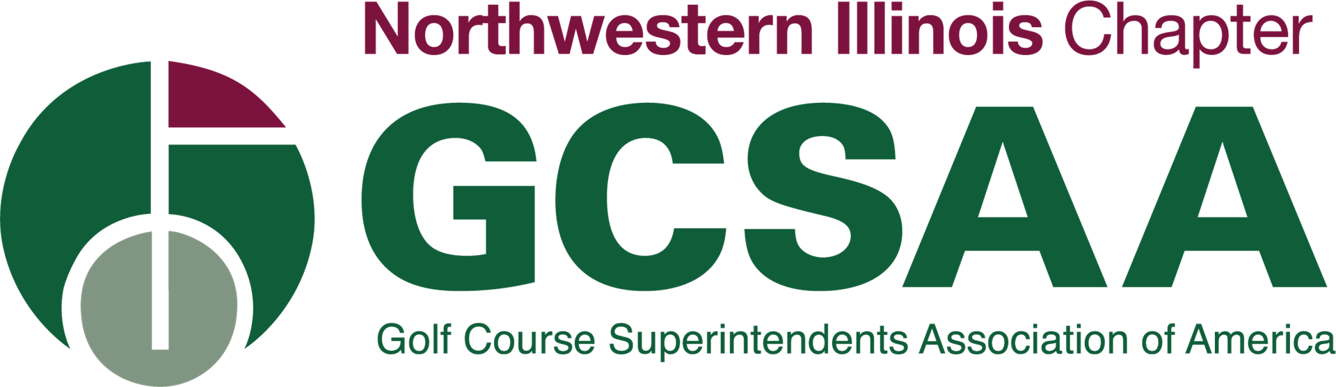

Application for GCSAA’s Conference and Show – San Diego, CA Feb. 7-10, 2022

Name:
Club:
Address:
City:
State:
Zip:
Email:
Mobile Phone:

Have you ever attended the GCSAA Conference and Trade Show (GIS) before?

Please list your work experience:

Please list your formal education:

What do you hope to gain from attending the 2022 Conference and Show?

I’m applying for:
___In Person
___Virtual
___Either

Essay: Please describe your greatest challenges living through the pandemic in both your personal and professional life and why. (500-1000 words)

Application deadline is December 10, 2021. Please email applications to luke@nwigcsa.com

